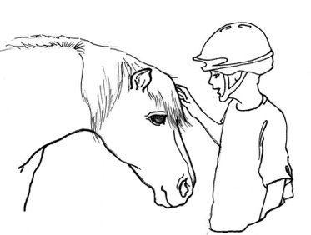
Enter His Gates Scholarship Form 2024

Name of Camper: ________________
Age: ________
Parent/parents/guardian name: ________________
Address: ______________________________________
Phone: ________________
Email: ______________________

School camper attends: ___________________
First time camper: ___ Yes ___ No
Week requesting scholarship: __________

Family income in 2023: __________
Tax return in 2023: _________

You may be asked to speak with a member of our staff. We will reach out after reviewing your application. Please fill out a camp application along with this form. Thank you for applying!

